**ASSIGNMENT 5**

**Guan Yue Wang**

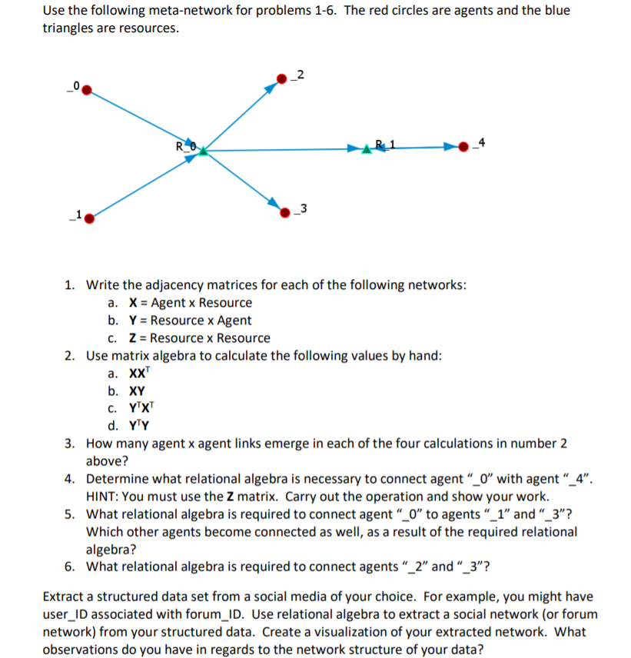

**1a**

X=

|  |  |  |
| --- | --- | --- |
|  | R_0 | R_1 |
| _0 | 1 | 0 |
| _1 | 1 | 0 |
| _2 | 0 | 0 |
| _3 | 0 | 0 |
| _4 | 0 | 1 |

**1b**

Y=

|  |  |  |  |  |  |
| --- | --- | --- | --- | --- | --- |
|  | _0 | _1 | _2 | _3 | _4 |
| R_0 | 0 | 0 | 1 | 1 | 0 |
| R_1 | 0 | 0 | 0 | 0 | 1 |

**1c**

Z=

|  |  |  |
| --- | --- | --- |
|  | R_0 | R_1 |
| R_0 | 0 | 1 |
| R_1 | 0 | 0 |

**2a**

X

|  |  |
| --- | --- |
| 1 | 0 |
| 1 | 0 |
| 0 | 0 |
| 0 | 0 |
| 0 | 1 |

XT

|  |  |  |  |  |
| --- | --- | --- | --- | --- |
| 1 | 1 | 0 | 0 | 0 |
| 0 | 0 | 0 | 0 | 1 |

XXT

|  |  |  |  |  |
| --- | --- | --- | --- | --- |
| 1 | 1 | 0 | 0 | 0 |
| 1 | 1 | 0 | 0 | 0 |
| 0 | 0 | 0 | 0 | 0 |
| 0 | 0 | 0 | 0 | 0 |
| 0 | 0 | 0 | 0 | 1 |

**2b**

X

|  |  |
| --- | --- |
| 1 | 0 |
| 1 | 0 |
| 0 | 0 |
| 0 | 0 |
| 0 | 1 |

Y=

|  |  |  |  |  |
| --- | --- | --- | --- | --- |
| 0 | 0 | 1 | 1 | 0 |
| 0 | 0 | 0 | 0 | 1 |

XY

|  |  |  |  |  |
| --- | --- | --- | --- | --- |
| 0 | 0 | 1 | 1 | 0 |
| 0 | 0 | 1 | 1 | 0 |
| 0 | 0 | 0 | 0 | 0 |
| 0 | 0 | 0 | 0 | 0 |
| 0 | 0 | 0 | 0 | 1 |

**2c**

YT

|  |  |
| --- | --- |
| 0 | 0 |
| 0 | 0 |
| 1 | 0 |
| 1 | 0 |
| 0 | 1 |

XT

|  |  |  |  |  |
| --- | --- | --- | --- | --- |
| 1 | 1 | 0 | 0 | 0 |
| 0 | 0 | 0 | 0 | 1 |

YT XT

|  |  |  |  |  |
| --- | --- | --- | --- | --- |
| 0 | 0 | 0 | 0 | 0 |
| 0 | 0 | 0 | 0 | 0 |
| 1 | 1 | 0 | 0 | 0 |
| 1 | 1 | 0 | 0 | 0 |
| 0 | 0 | 0 | 0 | 1 |

**2d**

YT

|  |  |
| --- | --- |
| 0 | 0 |
| 0 | 0 |
| 1 | 0 |
| 1 | 0 |
| 0 | 1 |

Y=

|  |  |  |  |  |
| --- | --- | --- | --- | --- |
| 0 | 0 | 1 | 1 | 0 |
| 0 | 0 | 0 | 0 | 1 |

YT Y

|  |  |  |  |  |
| --- | --- | --- | --- | --- |
| 0 | 0 | 0 | 0 | 0 |
| 0 | 0 | 0 | 0 | 0 |
| 0 | 0 | 1 | 1 | 0 |
| 0 | 0 | 1 | 1 | 0 |
| 0 | 0 | 0 | 0 | 1 |

**3.**

Five links

**4.**

To connect agent_0 to agent _4, we need XZY as below

X

|  |  |
| --- | --- |
| 1 | 0 |
| 1 | 0 |
| 0 | 0 |
| 0 | 0 |
| 0 | 1 |

Z

|  |  |
| --- | --- |
| 0 | 1 |
| 0 | 0 |

Y

|  |  |  |  |  |
| --- | --- | --- | --- | --- |
| 0 | 0 | 1 | 1 | 0 |
| 0 | 0 | 0 | 0 | 1 |

XZY

|  |  |  |  |  |
| --- | --- | --- | --- | --- |
| 0 | 0 | 0 | 0 | 1 |
| 0 | 0 | 0 | 0 | 1 |
| 0 | 0 | 0 | 0 | 0 |
| 0 | 0 | 0 | 0 | 0 |
| 0 | 0 | 0 | 0 | 0 |

**5.**

To connect agent_0 to agent _1, we need XXT, no other agent becomes connected.

To connect agent_0 to agent _3, we need XY, agent 2 also becomes connected as well

**6.**

To connect agent_2 to agent_3, we need YT Y

**Visualization of Facebook network**

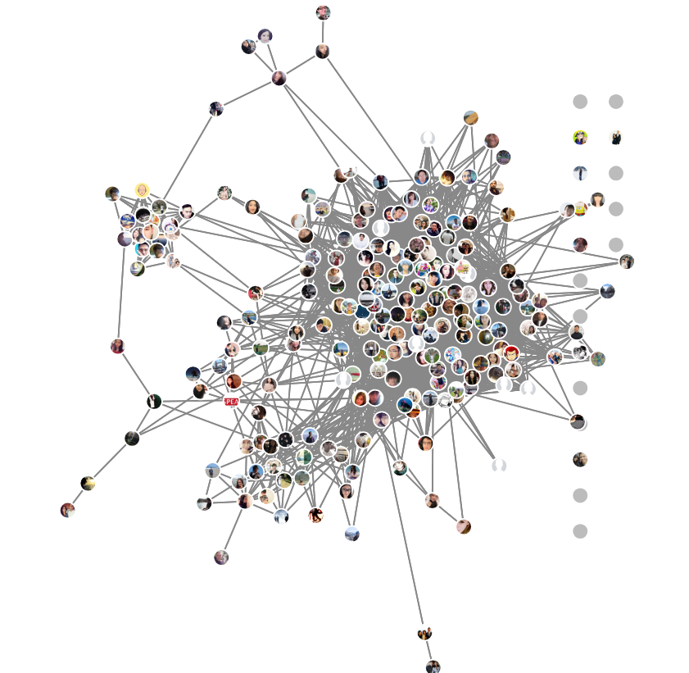

Observation: Lattice Network with mostly high school and university friends all connected to each other.